**Task Manager App Screenshots**

* **Backend APIs**

1. **Add a new task**

URL: <http://localhost:4000/tasks>

1. 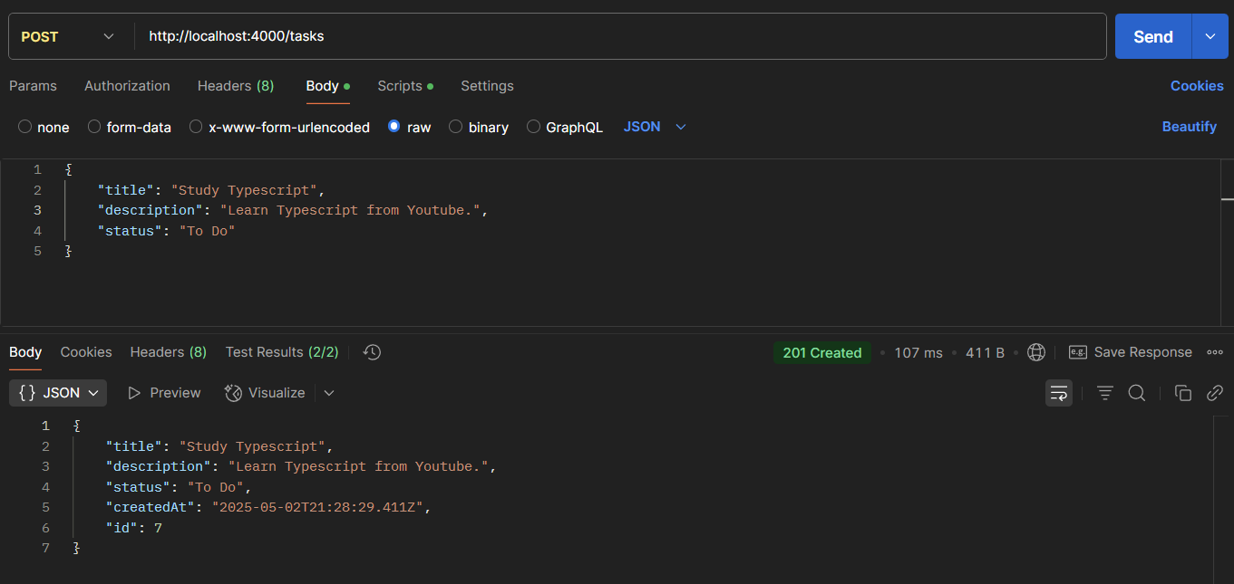**Happy Flow**

1. **A screenshot of a computer

   AI-generated content may be incorrect.Empty Request Body**
2. **A screenshot of a computer

   AI-generated content may be incorrect.Empty Task Title**
3. 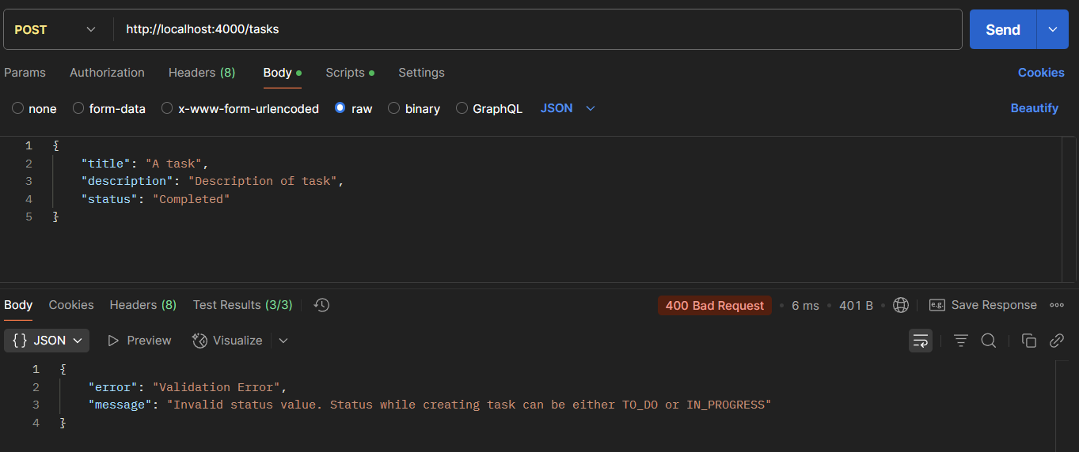**Invalid Task Status**
4. **Retrieve all tasks**

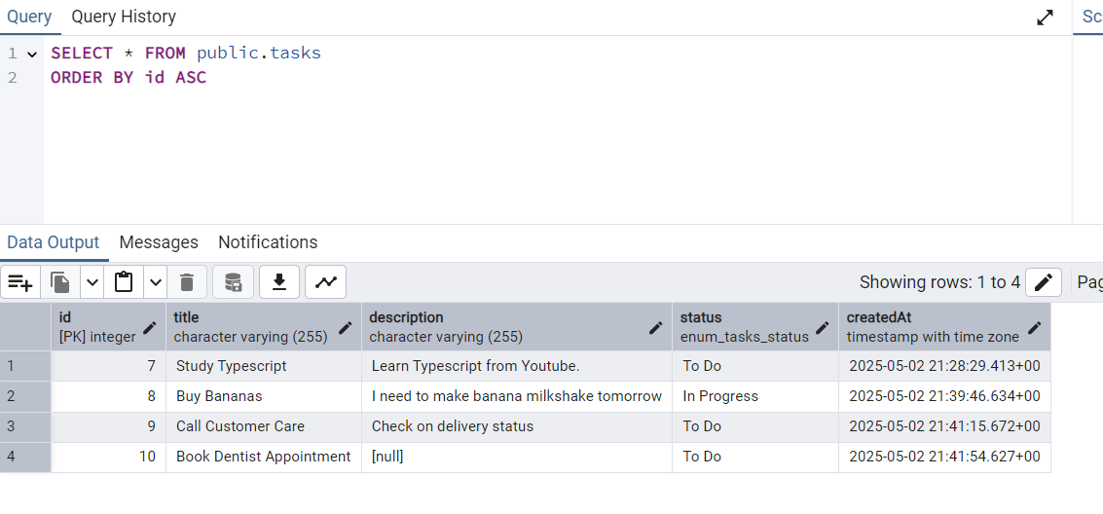URL: <http://localhost:4000/tasks>

1. **Update an existing task**

URL: [http://localhost:4000/tasks/{{id}}](http://localhost:4000/tasks/%7b%7bid%7d%7d)

1. **A screenshot of a computer

   AI-generated content may be incorrect.Happy Flow**

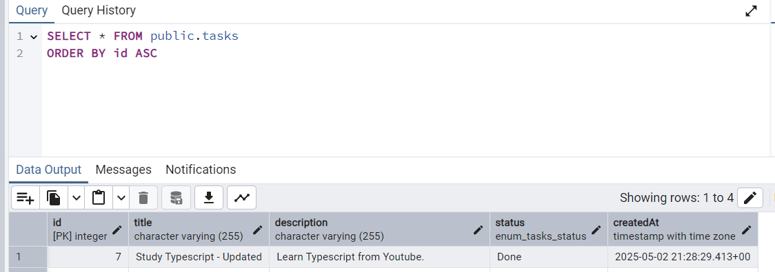

1. **Invalid Task Id**

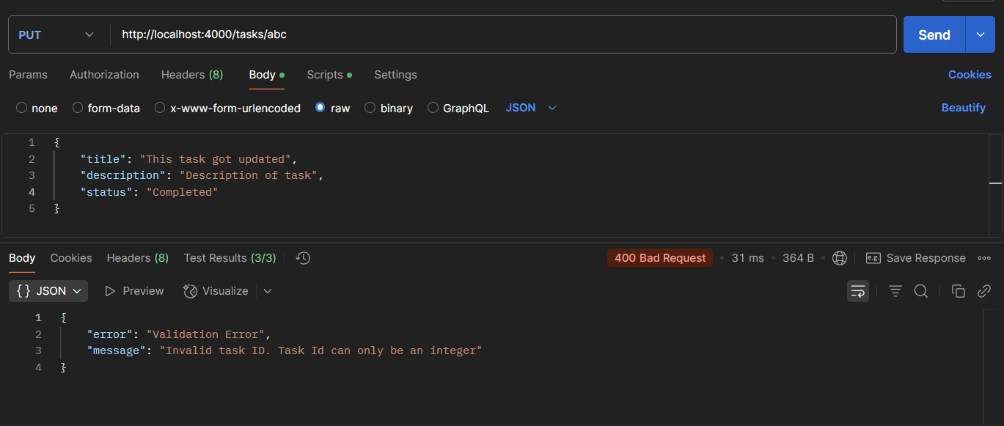

1. 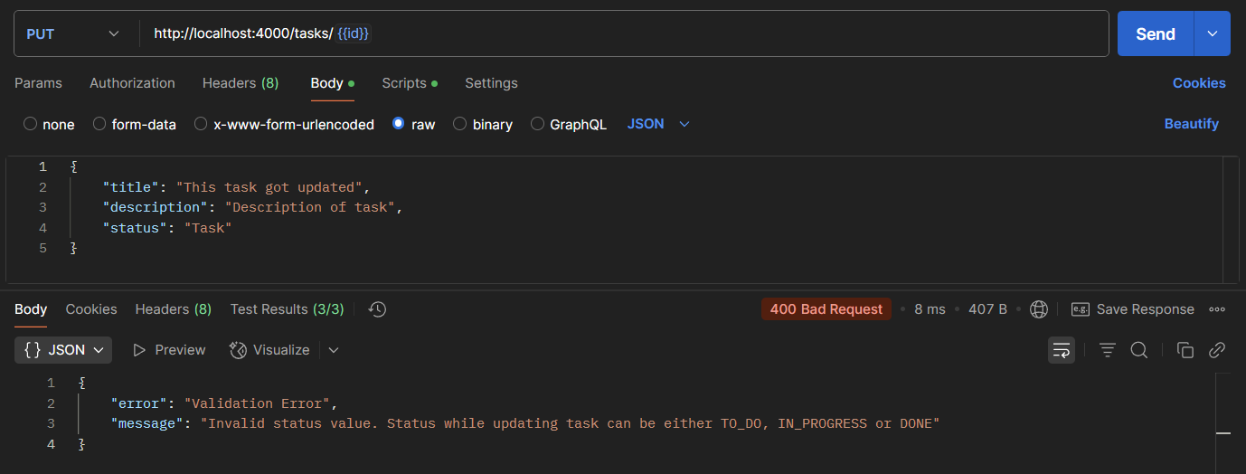**Invalid Status**
2. 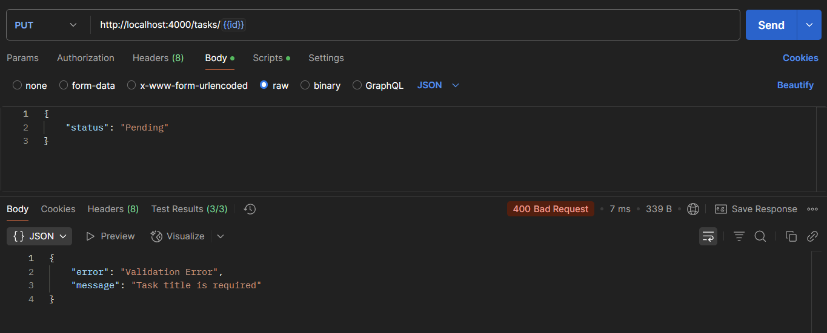**Empty Task Title**
3. 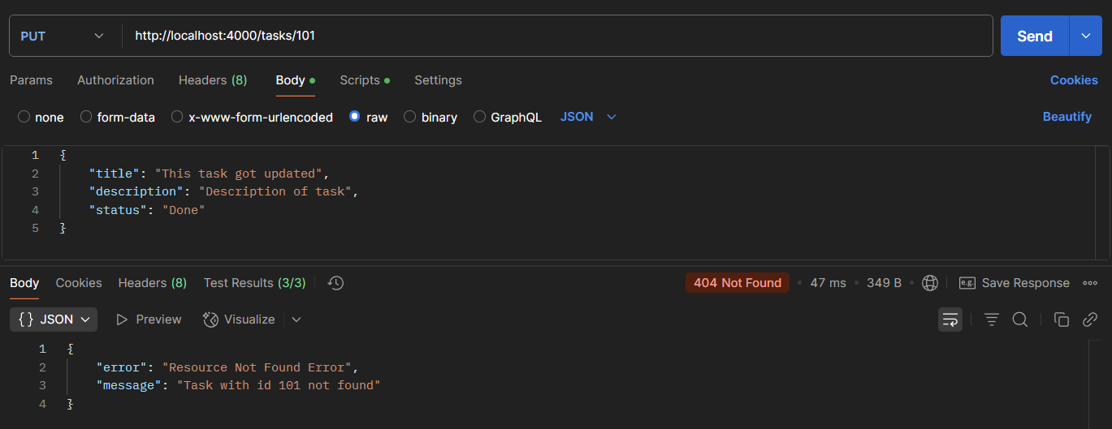**Task Id Not Found**
4. **Delete a task**

URL: [http://localhost:4000/tasks/{{id}}](http://localhost:4000/tasks/%7b%7bid%7d%7d)

1. 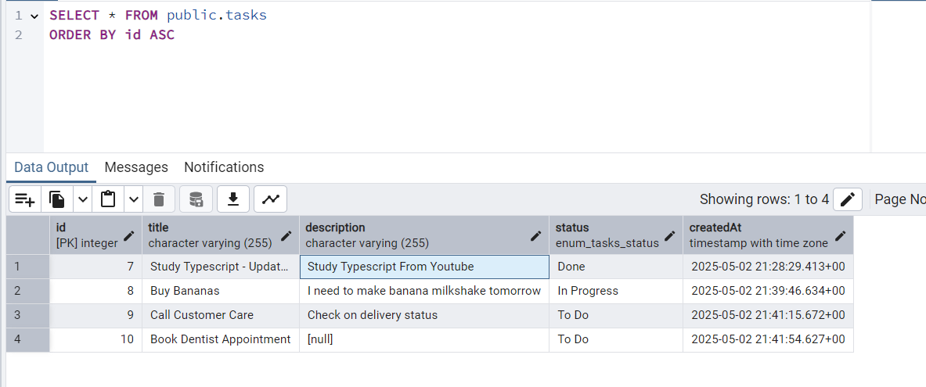**Happy Flow**

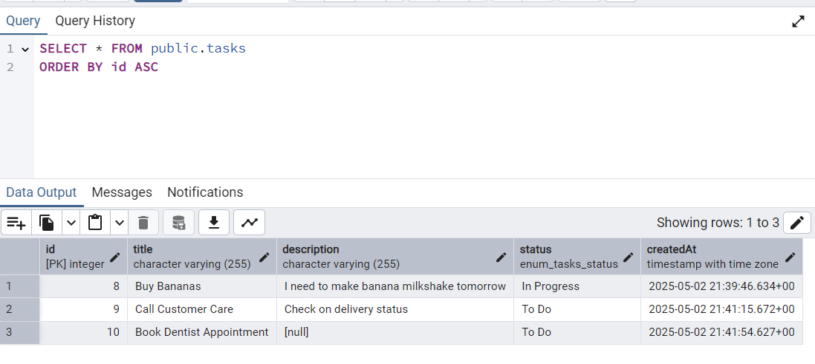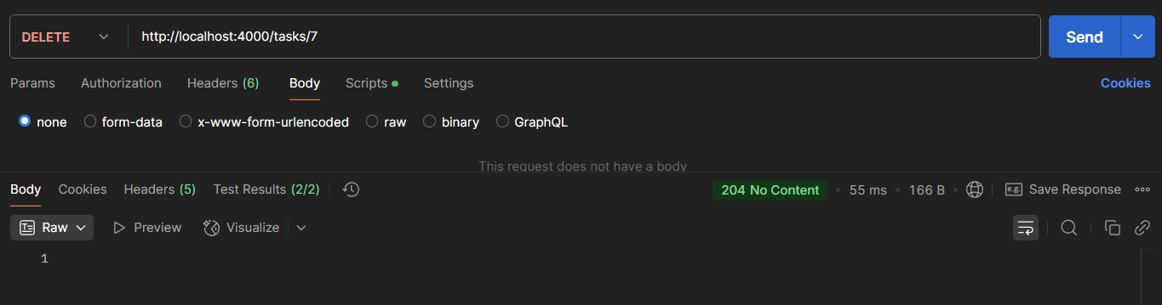

1. 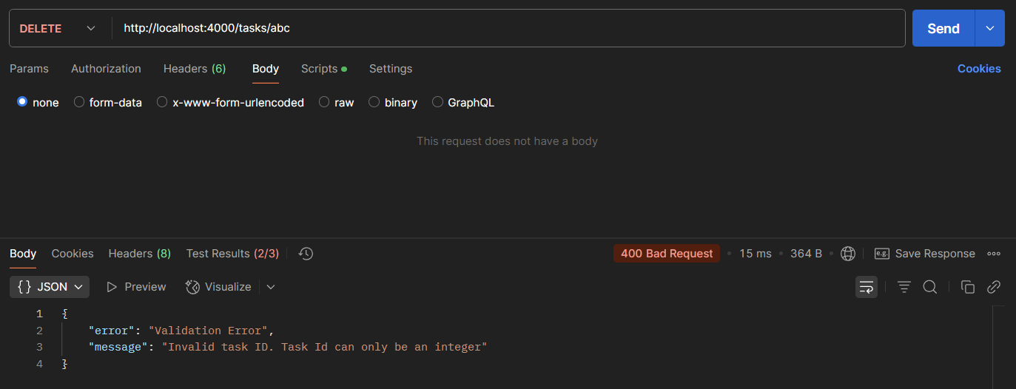**Invalid Task Id**
2. 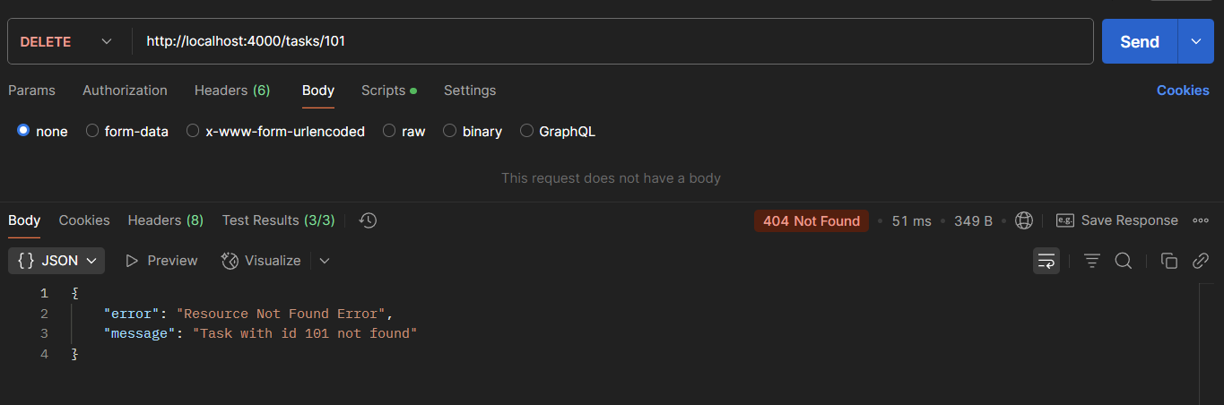**Task Id Not Found**

* **Frontend**

1. **Landing Page**

URL: <http://localhost:3000>

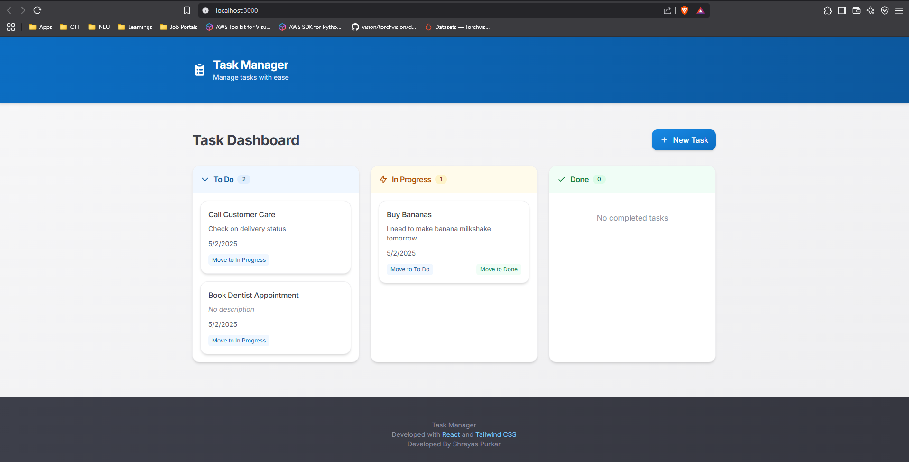

1. 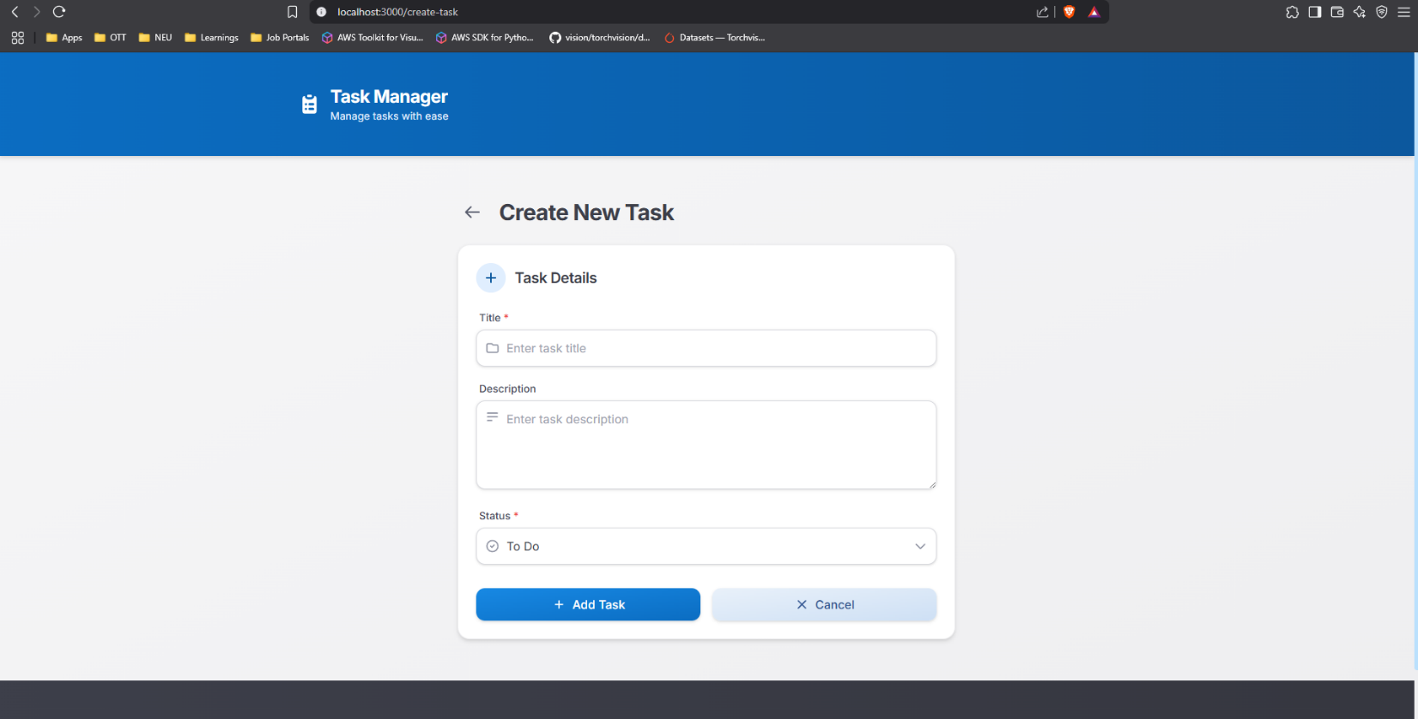**Create New Task – Click on New Task Button shown on landing page**

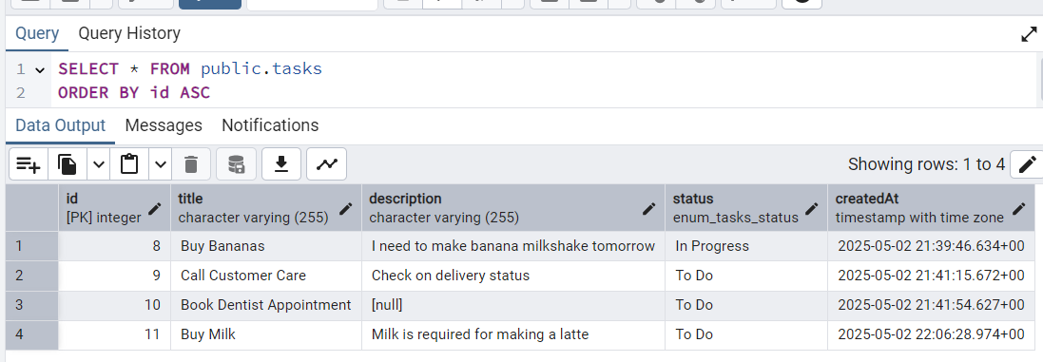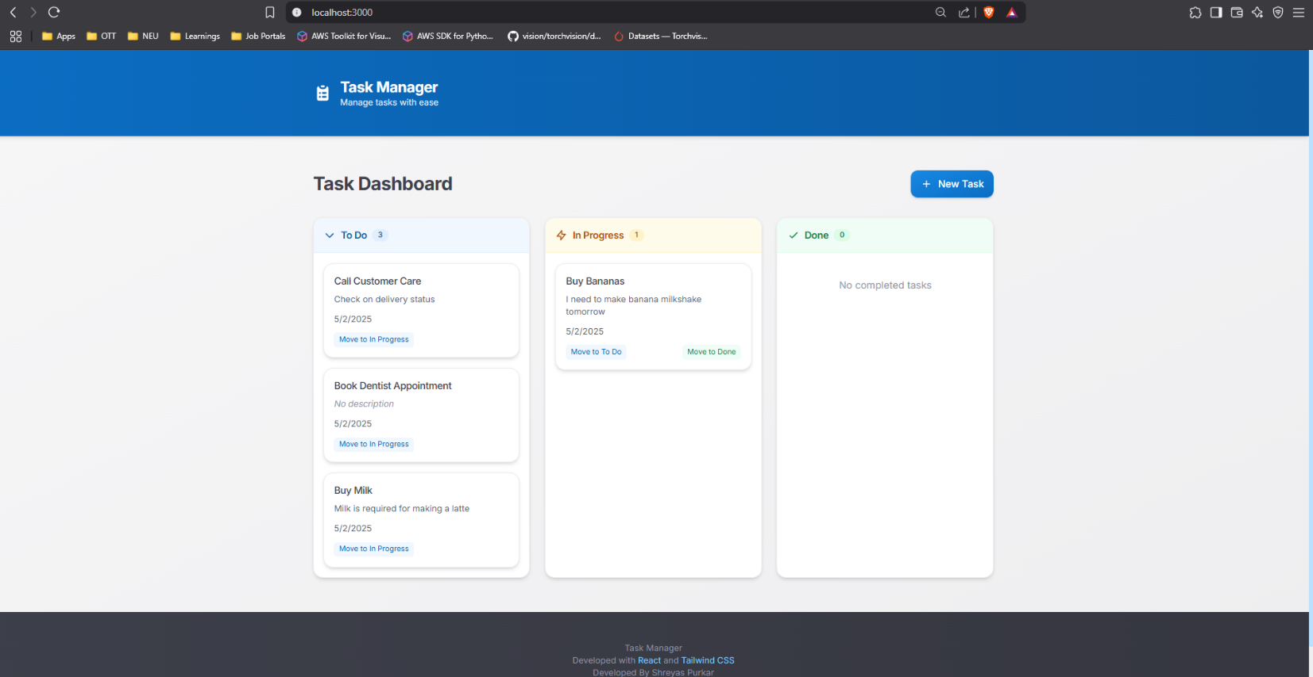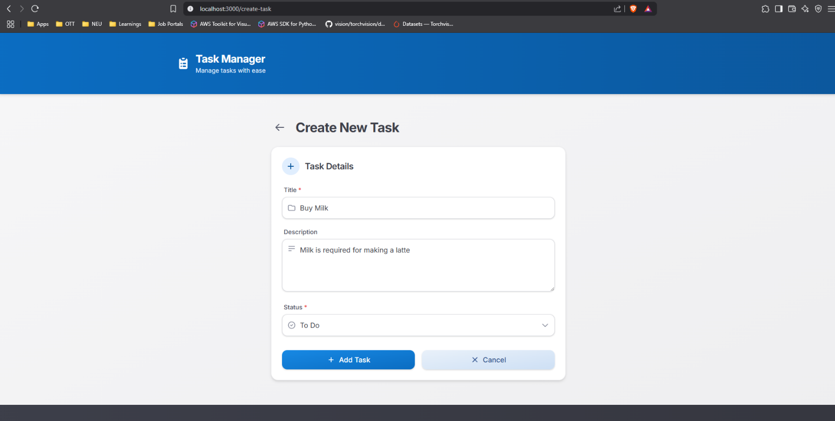

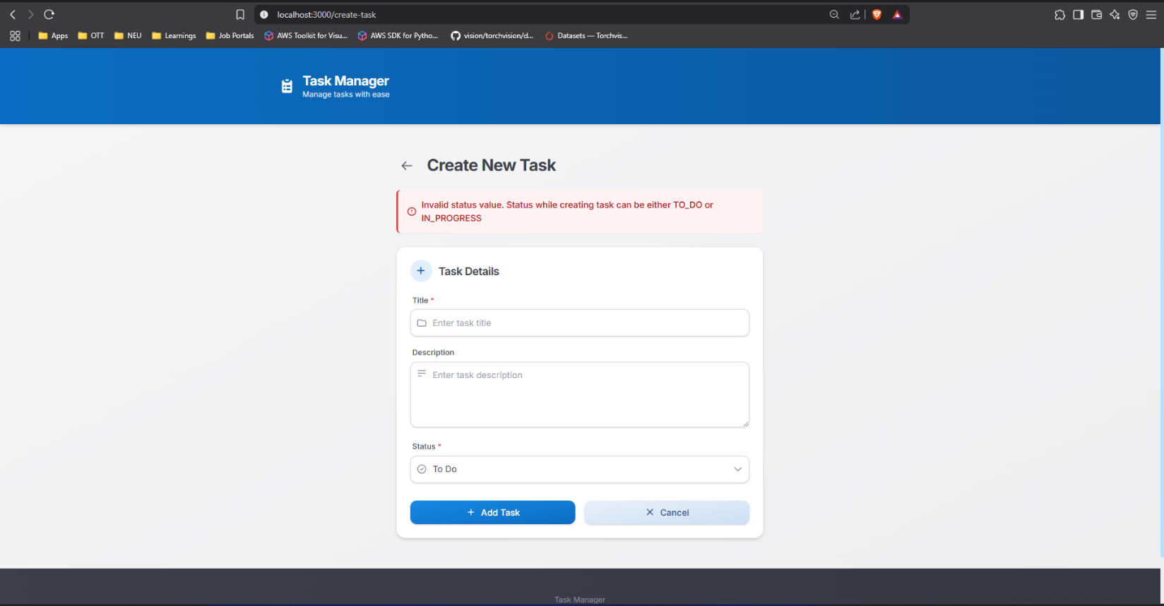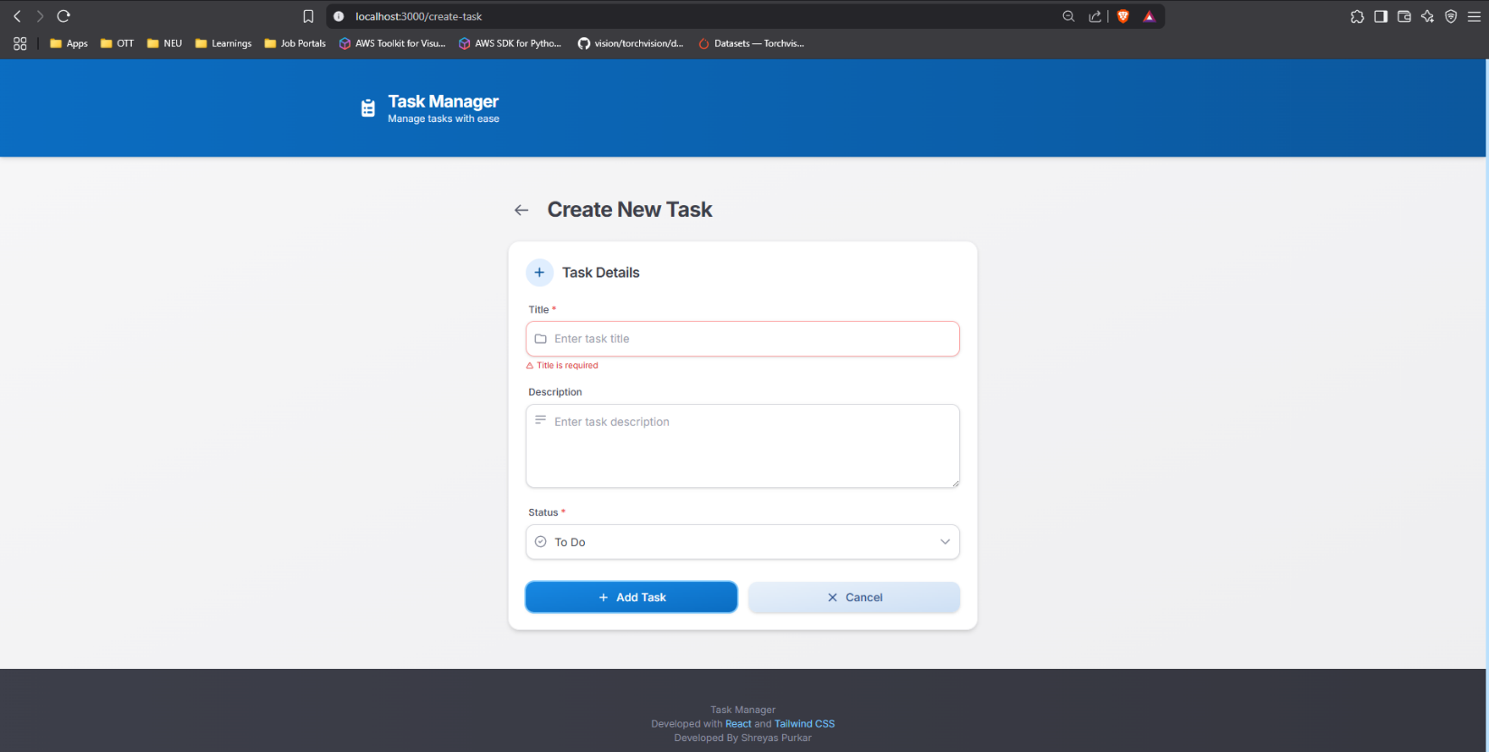

1. 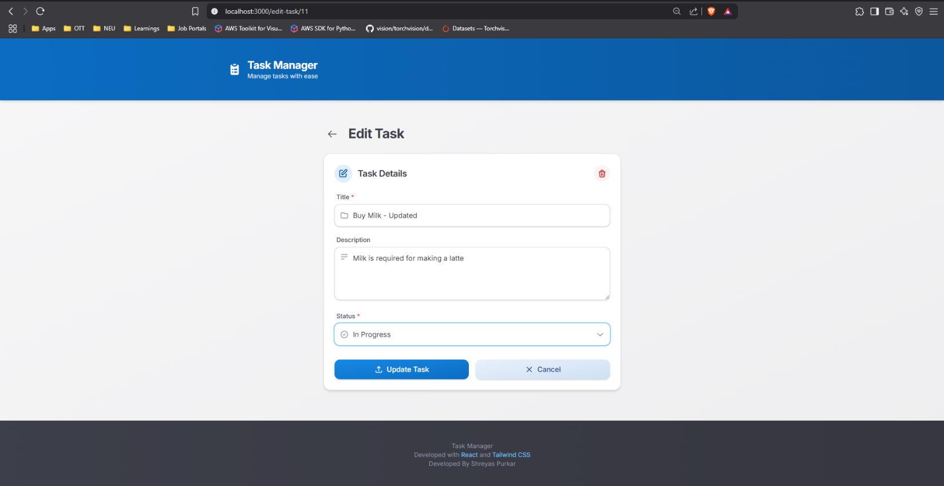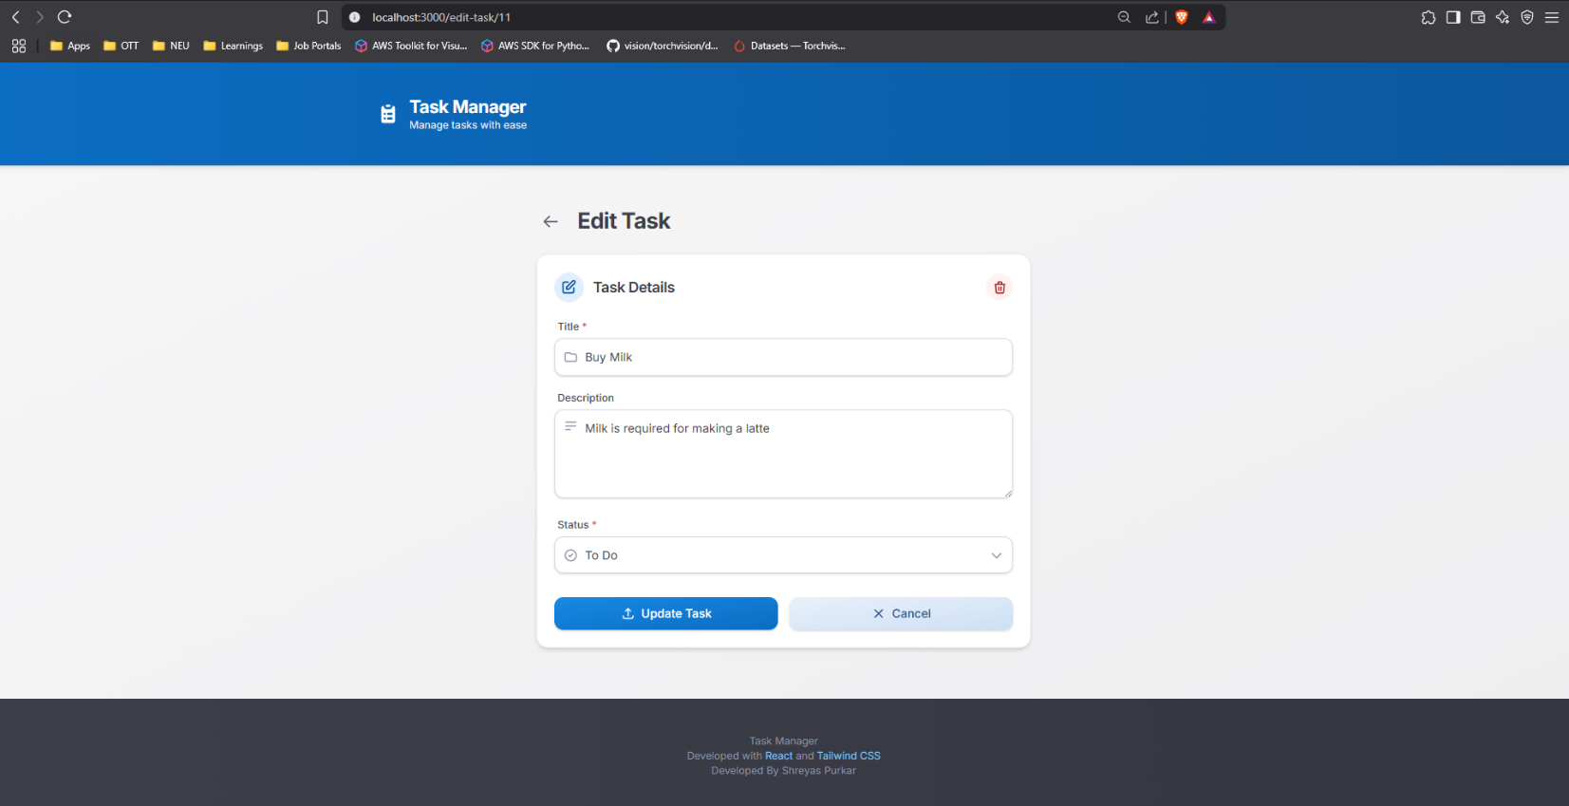**Edit Tasks - Click on task card, on landing page, of any status to edit it**

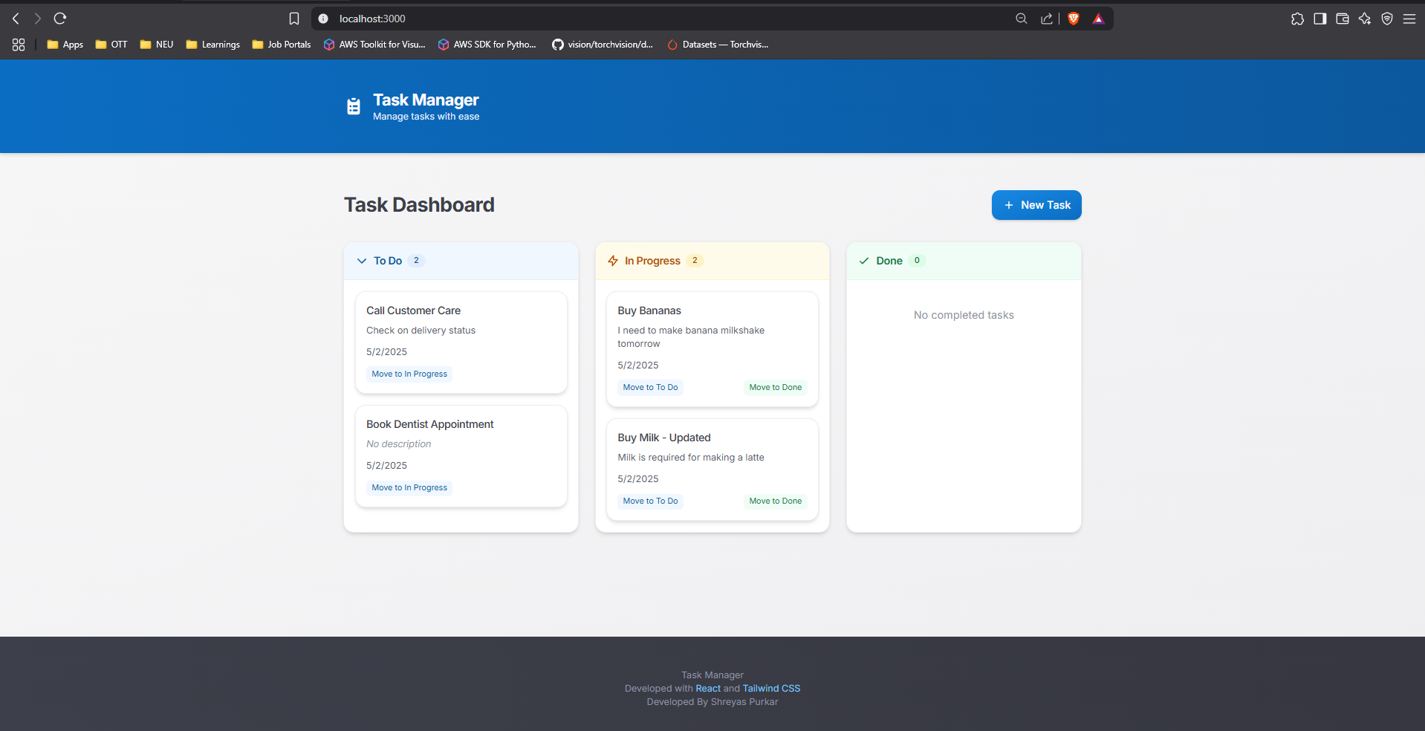

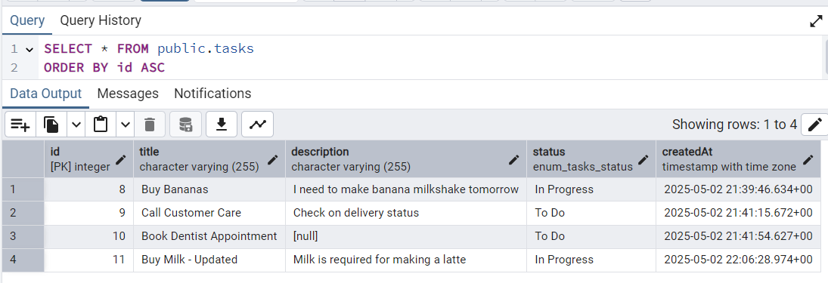

**Task’s status can also be updated directly by clicking on “Move to In Progress”, “Move To Do” and “Move to Done” labels on task cards**

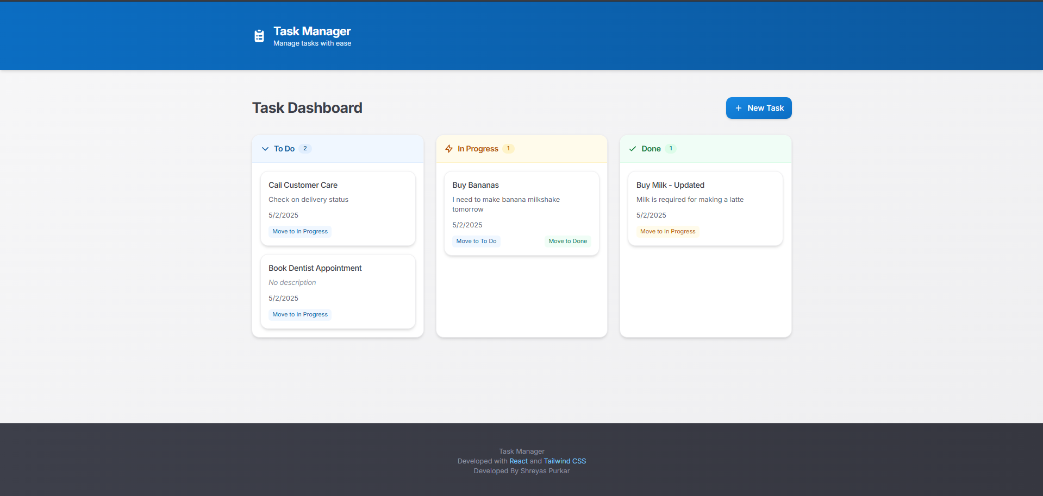

1. 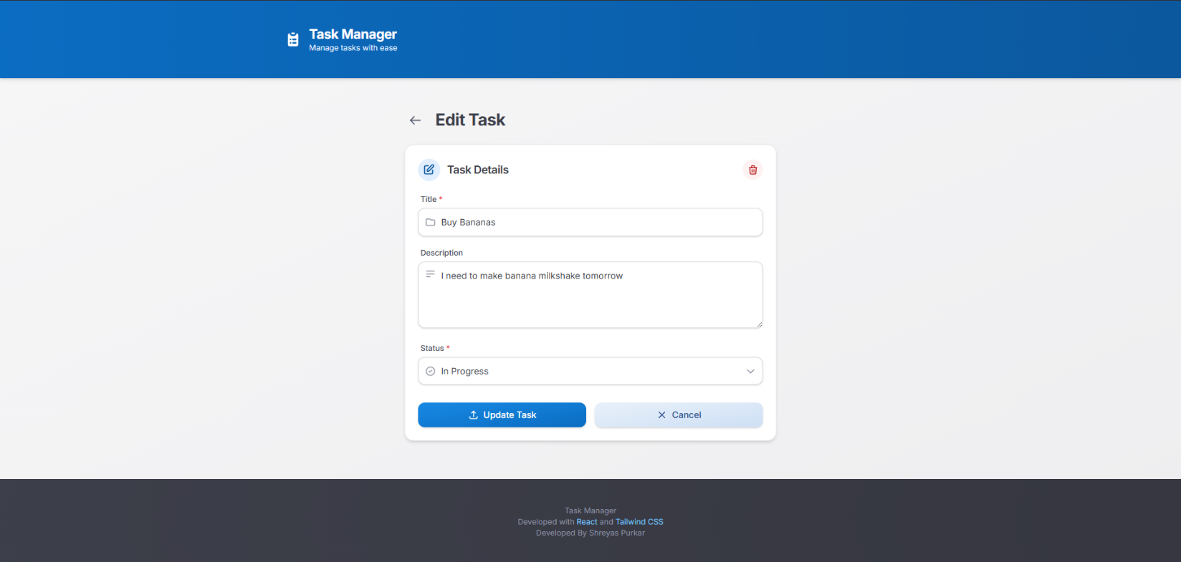**Deleting a Task – Click on the task card which needs to be deleted. Then click on delete icon on top right corner of edit task form.**

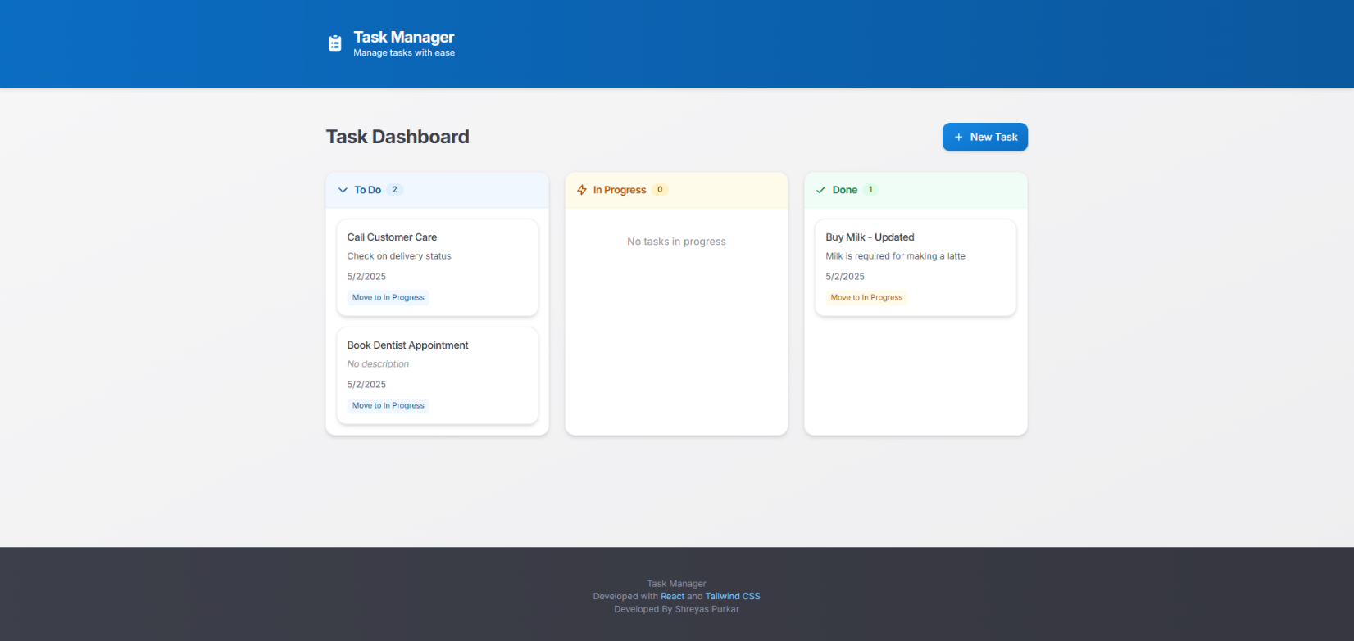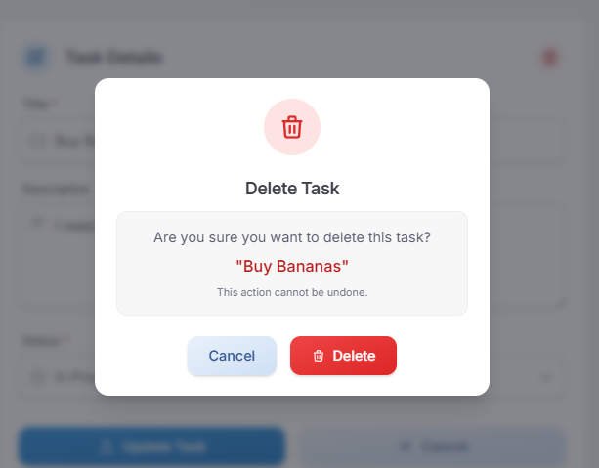

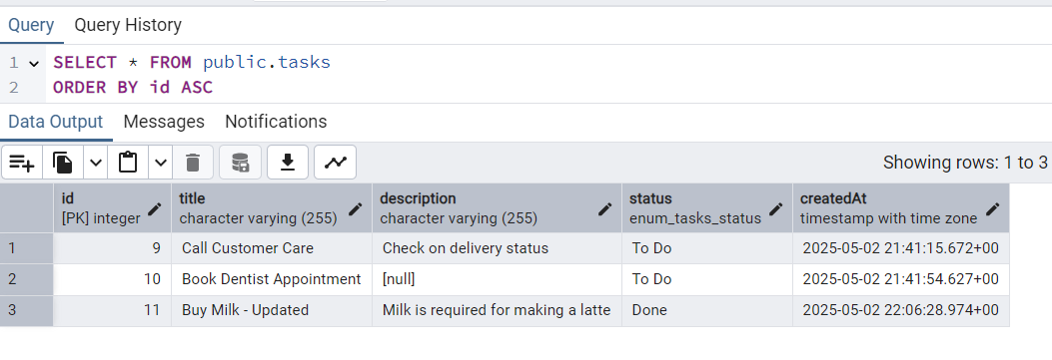

* **A screenshot of a computer

  AI-generated content may be incorrect.Regression Test Results**